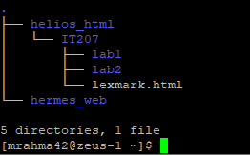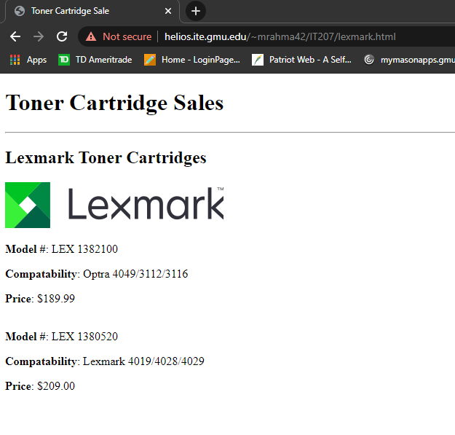

<https://helios.ite.gmu.edu/~mrahma42/IT207/lexmark.html>